Sales and EBITDA forecast.

Baseline.
In order to forecast future profits one can assume that their main determinator is a harvest. As harvest is known by the end of 1st half of financial year one can expect to be able to forecast 3rd and 4th quarter results based on 1st and 2nd quarter performance. So, our baseline forecast will be based on H1 results.
For example, there is a strong seasonal pattern for bulk sales of sunflower oil EBITDA. 1st quarter brings 14.4% of annual EBITDA, 2nd – 32.9%, 3rd – 24.0%, 4th – 28.7%. So, given 1st quarter $10.6 mio and 2nd quarter $29.6 mio result, one can expect $19.9 mio and $23.8 mio EBITDA for 3rd and 4th quarters correspondingly.
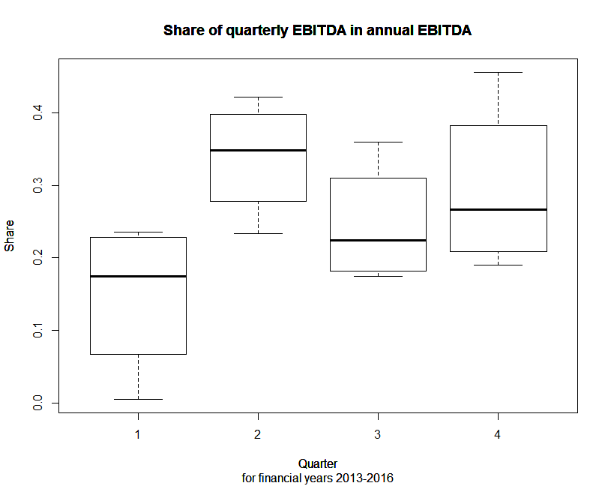
In the same way other segments’ EBITDA is forecasted. Only Farming and Other expenses can’t be forecasted similarly due to absolutely unpredictable fluctuations. So, simple average is used in order to forecast these two segments’ performance.
EBITDA, $ mio | 2017-III | 2017-IV
Bulk oil | 20 | 24
Bottled oil | 3 | 3
Grain export | 20 | 5
Export terminal | 10 | 7
Silo services | 8 | -1
Farming | 35 | 35
Other | -9 | -9
TOTAL | 87 | 63

Factor analisys.
The problem with above method is that it assumes the harvest is the only factor of Company performance. Other factors may be: prices for main traded commodities (sunflower oil, corn, wheat), prices of the inputs (diesel, fertilizers, salaries), Ukrainian hryvnya FX rate, VAT refunding rate, etc.
Baseline approach will be used in volumes forecasting. Historical and forward prices for commodities will be used in prices forecasting.
Bulk sunflower oil segment.
First of all, it is worth to look at sales price behavior. Except four outliers (marked by dashed line) Company charges its clients a price nearly equal to US Gulf Coast price. So, the estimated future price is the forward price in US Gulf Coast.

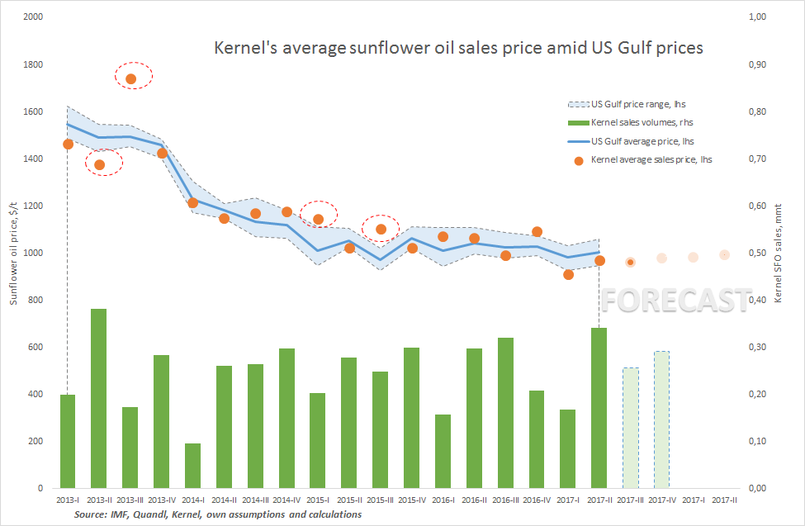
Bottled sunflower oil segment.
Prices of bottled sunflower oil sales are forecasted based on a previous quarter bulk sunflower oil prices.
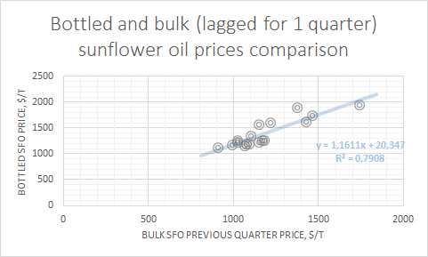
Grains segment.
Kernel grains sales prices are constantly above Chicago benchmarks. Notably, there are some outliers in same periods as with sunflower oil prices (3rd Q of 2013 and 1st Q of 2015).
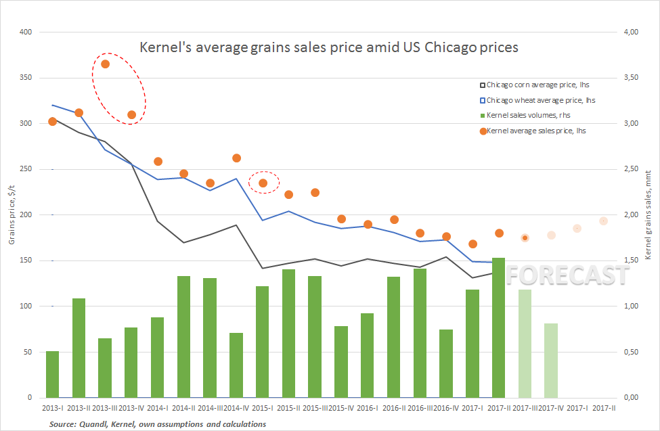
Export terminal segment.
Export terminal price of transshipment decreased constantly to the level of $13/t. It is assumed to stay on this level for a while.
Silo services segment.

Farming segment.

